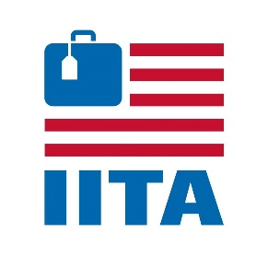
SAMPLE LETTER TO YOUR MEMBERS OF CONGRESS
Find your HOUSE Representative
Find your SENATORS
(Fill in the blank with your and your company information)

Dear (Congresswoman/Congressman or Senator):
I own an international inbound travel company that focuses solely on international travel to the United States and my business has been completely shut down since the federally-mandated border closures in March 2020.
I seek your assistance in securing relief funding for inbound tour operators based across the U.S. who promote international travel to the United States.
Inbound tour operator companies like mine facilitate inbound travel services for (describe your business, for example “independent and group travelers” or “meetings and events”), selling U.S. destinations to international tour operators, corporate travel buyers and travel agents. We drive international business to other travel and hospitality sectors, like hotels, transportation companies, attractions and restaurants.
My company has had no revenue for 14 months, yet we have had to maintain operations throughout that time in order to handle cancelations, postponements and new bookings for 2022 all without revenue.
In cooperation with our industry association – the International Inbound Travel Association (IITA), we support the Securing Access for Venue Equity (SAVE) Act (H.R. 2120) that would make inbound tour operators eligible for the Shuttered Venue Operator Grants program.
The SAVE Act, sponsored by Representatives Mark Amodei of Nevada, Charlie Crist of Florida, Dina Titus of Nevada, and Bill Pascrell of New Jersey, provides more resources for SVOGs and specifically make it possible for companies like inbound tour operators to be eligible. We urge you to co-sponsor this legislation and help our company stay in business to welcome international travelers back to the United States.
Whether it's the SVOG program or other relief and stimulus legislation, inbound tour operators need financial support to keep the lights on as we work our way back to normal inbound travel patterns.
I would be happy to meet with you by phone or video call for further discussions. Otherwise, I can be reached at (phone number) or (email address).
Thank you for your help.
Best regards,
(Your Name)
(Your Title)
(Your Company Name)

